In Java, the java.util.Arrays class provides utility methods for working with arrays. It doesn’t define a new type of array, but rather offers methods that simplify many common array operations. Here’s a comparison of **basic arrays** and **methods in the**

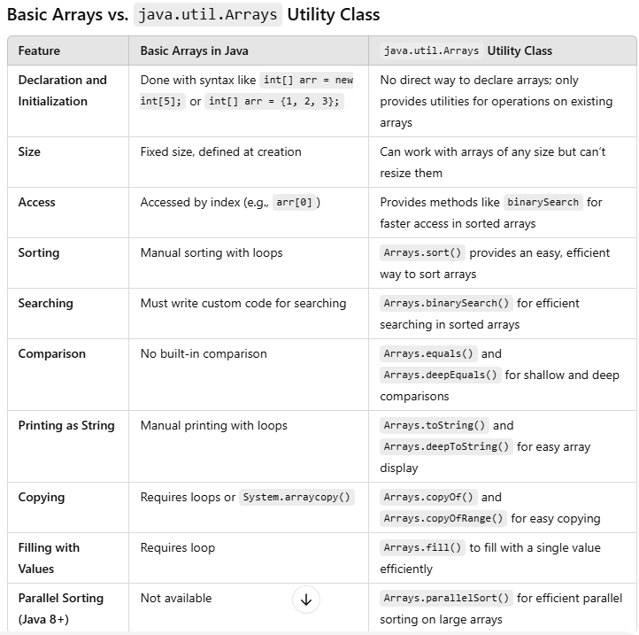**java.util.Arrays class**, highlighting their respective capabilities and advantages.

